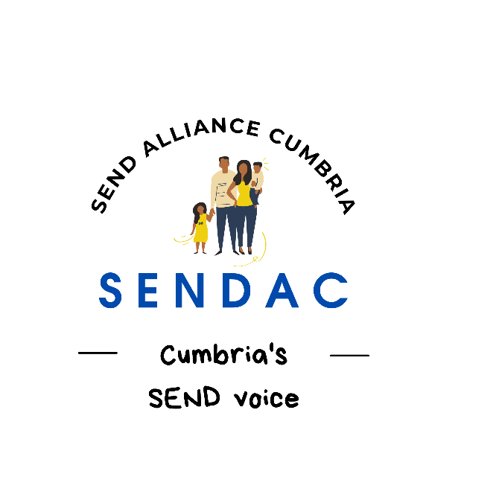

SEND Alliance Cumbria Constitution

- Name. SEND Alliance Cumbria (SENDAC)
N.B for the purpose of this document parent is defined broadly as anyone who has caring responsibilities for a child or young person aged 0-25 years with SEND
2) Aim.
• To work with the local authority, local NHS organisations, commissioners, service providers and families to enable services to be delivered in a child-centred, personalised and effective way, based on the principle of early intervention for children 0-25 years with special educational needs and or disabilities.
• To build skills, confidence and teamwork of individual parent/carers and between parent carer groups so that together we raise awareness of our children and young people’s needs and recognition of our role as parent carers in true participation to achieve a coproduction model with partner agencies, and the SEND community/network
• To be representative of and to engage with as many parent carers as possible, including seldom heard groups of parent carers.
• To develop and build good practice mechanisms to better engage with parent family carers and wider family.

3) Powers
In order to achieve its aim the Forum may:
a) Raise money
b) Open bank accounts
c) Rent premises
d) Take out insurance from an agreed provider
e) Employ staff
f) Submit an agreed invoice
g) Organise courses and events
h) Work with similar Groups and exchange information and advice with them subject to GDPR
i) Develop an annual action plan
j) Report to partner agencies annually on membership numbers, gender, ethnicity and geography. They will also report on outcomes.
k) Do anything that is lawful which will help it to fulfil its aim.

4) Membership.
a) Membership of the Forum shall be open to any parent, family member or carer of a child or young person aged 0-25 years, who is over 18 years and resident in Cumbria without regards to disability, political or religious affiliation, race, sex or sexual orientation who is:
Interested in helping the Forum to achieve its aim and
Willing to abide by the rules of the Forum and adhere to the Team expectations policy
5) Management of the Steering Group.
a) Membership shall be open to any SENDAC member who is willing to be an active participant, so long as the maximum number of members is not exceeded.
a) The Steering Group shall be quorate if at least three people are present
b) The Steering Group will have two Co-chairs, ideally by north and south division, a Treasurer and a Secretary. Other members of the Group may have lead responsibility areas, for example in Education and any other roles necessary to ensure the group runs efficiently. There will be a maximum number of 18 steering group members.
c) The steering group may co-opt onto the steering group. Co-opted members will be individuals in an advisory and non-voting capacity that the steering group feels will help to fulfil the aims of the Group.
d) The steering group shall meet at least three times a year in closed session. Any other committee meetings will be open to forum members in a nonvoting capacity.
e) Voting at steering group meetings shall be by a show of hands. If there is a tied vote then the co-Chairpersons chairing the meeting shall have a second vote.
f) The steering group shall have the power to remove any member of the steering group for good and proper reason, as set out in the Code of Conduct.
g) The steering group may appoint any other member of the forum as a steering group member to fill a vacancy, provided that the maximum prescribed is not exceeded.
h) Steering group members must provide reasons for non attendance at meetings, apologies for non attendance must be accepted by the steering group.
i) Any steering group member who is absent from three consecutive meetings may be asked to resign if appropriate to do so.
6) The Duties of the Steering Group Officers.
a) The duties of the Co -Chairpersons shall be to:
• Chair meetings of the Steering Group and the Forum
• represent the Group or Forum at functions/meetings that the Group or Forum has been invited to when appropriate and
• act as the spokesperson of the Group or Forum when necessary.
b) The duties of the Secretary shall be to:
• keep a membership list
• prepare in consultation with the Co-Chairpersons the agenda for meetings of the Steering Group and the Forum
• take and keep minutes of all meetings and
• collect and circulate any relevant information within the Steering Group.
c) The duties of the Treasurer shall be to:
• supervise the financial affairs of the Forum
• keep proper accounts that show all monies received and paid out by the Forum and
- adhere to the Financial Control Policy

7) Finance.
See Financial Control Policy.

8) Annual General Meeting.
a) The Forum shall hold an Annual General Meeting (A.G.M.) in the month of October. The first AGM shall be held in 2023.
b) All Forum members shall be given at least fourteen days notice of the A.G.M. and shall be entitled to attend and vote.
c) The business of the A.G.M. shall include:
- receiving a report from the Chairperson on the Forum’s activities over the year
- receiving a report from the Treasurer on the finances of the Forum
- electing a new Steering Group
- considering any other matter as may be decided.

d) At least 5 Forum members must be present for the Annual General Meeting and any other General Meeting to take place

9) General Meetings.
a) There shall be at least 3 Meetings for all Forum members (excluding the A.G.M) each year.
10) Special General Meeting.
A Special General Meeting may be called by the Steering group to discuss an urgent matter. The Secretary shall give all Forum members fourteen days notice of any Special General Meeting together with notice of the business to be discussed.

11) Alterations to the Constitution.
Any changes to this Constitution must be agreed by at least two-thirds of those members present and voting at any Closed Steering Group Meeting.

12) Dissolution.
The Forum may be wound up at any time if agreed by two-thirds of those members present and voting at any Closed Meeting. In the event of winding up any assets remaining after all debts have been paid shall be determined by the Steering Group and in line with any grant conditions.

13) Adoption of the Constitution.
Until the first A.G.M. takes place the persons whose names, and signatures appear at the bottom of this document shall act as the Steering Group referred to in this constitution.
This Constitution was adopted on behalf of the Forum by the Steering Group on .........................................

- Name…………..…………………………………………………………………………

Signed ………………….............................................................................................

- Name………………………………………………………………………………………

Signed………………………………...........................................................................

- Name………………………………………………………………………………………

Signed…………………….................................……………......................................

- Name………………………………………………………………………………………

Signed…………………….................................……………......................................

- Name………………………………………………………………………………………

Signed…………………….................................……………......................................

- Name………………………………………………………………………………………

Signed…………………….................................……………......................................

- Name………………………………………………………………………………………

Signed…………………….................................……………......................................

- Name………………………………………………………………………………………

Signed…………………….................................……………......................................

PLEASE NOTE- This policy is at the end of our first review since being adopted and therefore, is not signed.

Policy version information
Policy adopted
Policy last reviewed
Policy approved by Board

